**1.01: Setting Up a MongoDB Atlas Account**

MongoDB Atlas offers you free registration to set up a free cluster.

1. Go to [https://www.mongodb.com](https://www.mongodb.com/) and click **Start free**.
2. If you have a Google account, you can sign in using it. This is the most convenient way.
3. Otherwise, you can sign up a free account.

**1.02: Setting Up a MongoDB Atlas Organization**

You have successfully created an account on MongoDB Atlas, you will set up an organization based on your preferences:

1. Log on to your MongoDB account created in *1.01*, *Setting Up a MongoDB Atlas Account*. To create an organization, select the **Organizations** option from your account menu as shown in the following figure:

Figure: User options – Organizations

1. You will see the default organization in the list of organizations. To create a new organization, click the **Create New Organization** button in the top-right corner:

Figure 1.8: Organizations list


Figure: Organizations list

1. Type the organization name in the **Name Your Organization** field. Leave the default selection for **Cloud Service** as **MongoDB Atlas**. Click **Next** to proceed to the next step:

Figure 1.9: Organization Name


Figure: Organization Name

You will be presented with the following screen:

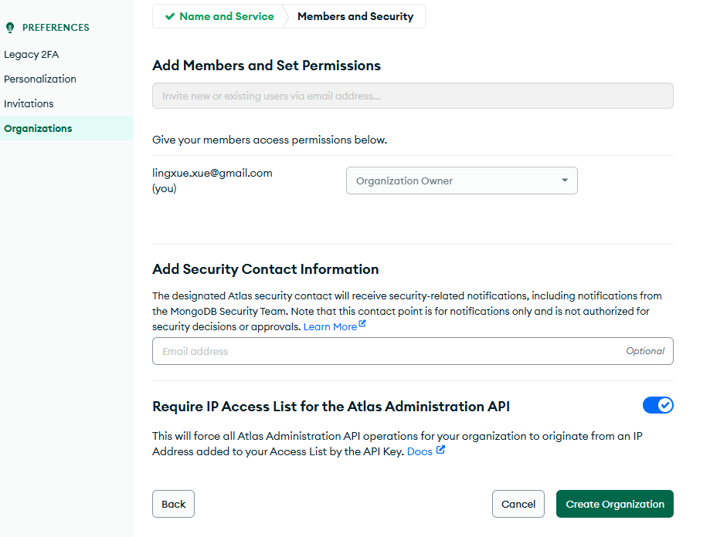

Figure: Create Organization page

1. You will see your login as the **Organization Owner**. Leave everything as their defaults and click **Create Organization**.

Once you have successfully created the organization, the following **Projects** screen will appear:

Figure 1.11: Projects page


Figure: Projects page

**1.03: Creating a MongoDB Atlas Project**

1. Once you have created an organization in *1.02*, *Setting Up MongoDB Atlas Organization*, the **Projects** screen will appear on your next login. Click **New Project**:

Figure 1.12: Projects page


Figure: Projects page

1. Provide a name for your project on the **Name Your Project** tab. Name the project **myMongoProject**. Click **Next**:

Figure 1.13: Create a Project page


Figure: Create a Project page

1. Click **Create Project**. The **Add Members and Set Permissions** page is not mandatory, so leave it as the default. Your name should appear as the **Project Owner**:

**1.04: Setting Up Your First Free MongoDB Cluster on Atlas**

In this section, you will set up your first MongoDB replica set on Atlas free tier (M0). Here are the steps to do this:

1. Go to <https://www.mongodb.com/cloud/atlas> and log on to your account using the credentials that you used in *1.01*, *Setting Up a MongoDB Atlas Account*. The following screen appears:

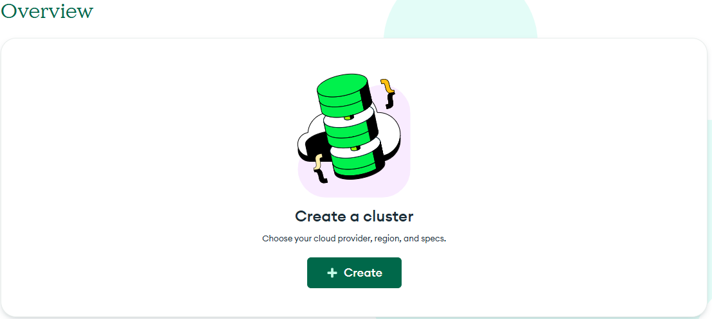

Figure: Cluster page

1. Click +**Create** to configure your cluster:

Figure: Configure Deployment

1. Select the **M0** option marked as **FREE**.
2. Select **AWS** for Provider.
3. Select the **Recommended region** that is closest to your location and is free. In this case, you are selecting **N. Virginia**.
4. Click **Create Deployment.**

Figure: FREE Create

Your deployment will be created.

1. Once this is done, you will be directed to a page for **Connect to Cluster**.

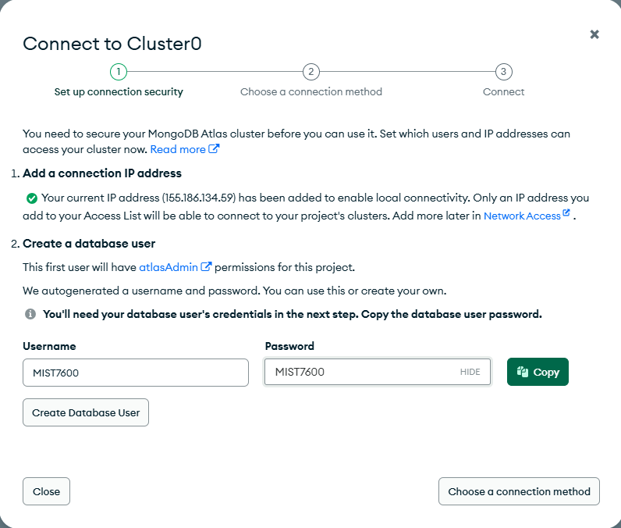

You need to **Create User** as show above.

Next, click **Choose a connect method.**

Click **Compass**, you see the next page:

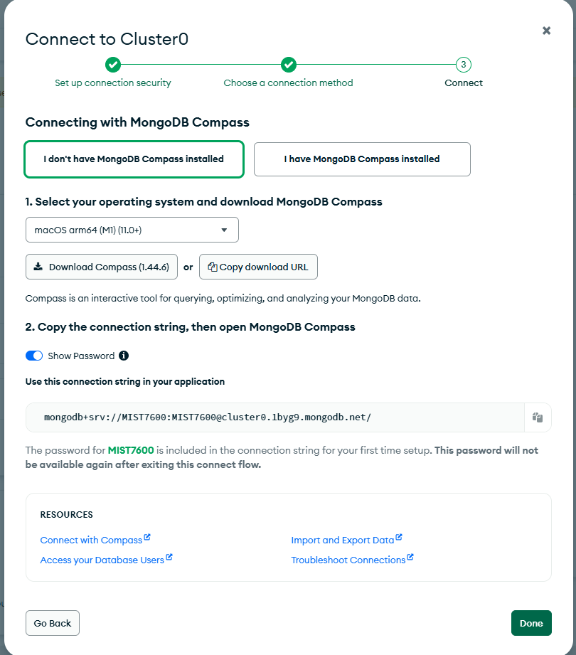

1. If you do not have Compass installed, follow Step 1 on the page to download and install **Compass**.
2. If you have Compass installed, then you can come back, choose “**I have MongoDB Compass installed**”, and use the connection string provided in Step 2 to add connection in your MongoDB Compass.